Predictive control and optimization of sustainable energy systems
Sektorkopplung und Flexibilität
Bernhard THALER⁽¹⁾, Michael WOHLTAN⁽¹⁾, Stefan POSCH⁽¹⁾, Gerhard PIRKER⁽¹⁾ , Andreas WIMMER^{(1,2)}

⁽¹⁾Large Engines Competence Center Graz, ⁽²⁾Graz, University of Technology

Motivation
The energy transition to a renewable-based system poses challenges for robust system design and optimal operation. Energy system optimization tackles these challenges by using highly time-resolved data to find optimal setups and energy management strategies. Coupling such optimizers to data-driven forecasts enables making use of resulting operating data for advanced controls. Here, a flexible optimization framework is presented that can be used for various applications, from power plants to macro-energy systems. As example application serves a study of an isolated industrial microgrid that relies on solar energy and seasonal hydrogen storage. Operation uses predictive-control with a receding horizon of 24 hours and data-driven forecast of renewables and system loads. Results are compared with a purely rule-based approach and an optimal strategy considering the full year.

Method
Simulations are performed with the optimization tool LEC ENERsim, which is based on mixed-integer linear programming. It enables the techno-economic assessment of generic energy systems that consist of sources, storage units, converters, and sinks. Systems consist of various components that are connected via energy flow connections. Components are parametrized with boundary data such as efficiencies, load and source power profiles, or energy market data. Figure 1 shows example systems that are set up in the described framework.

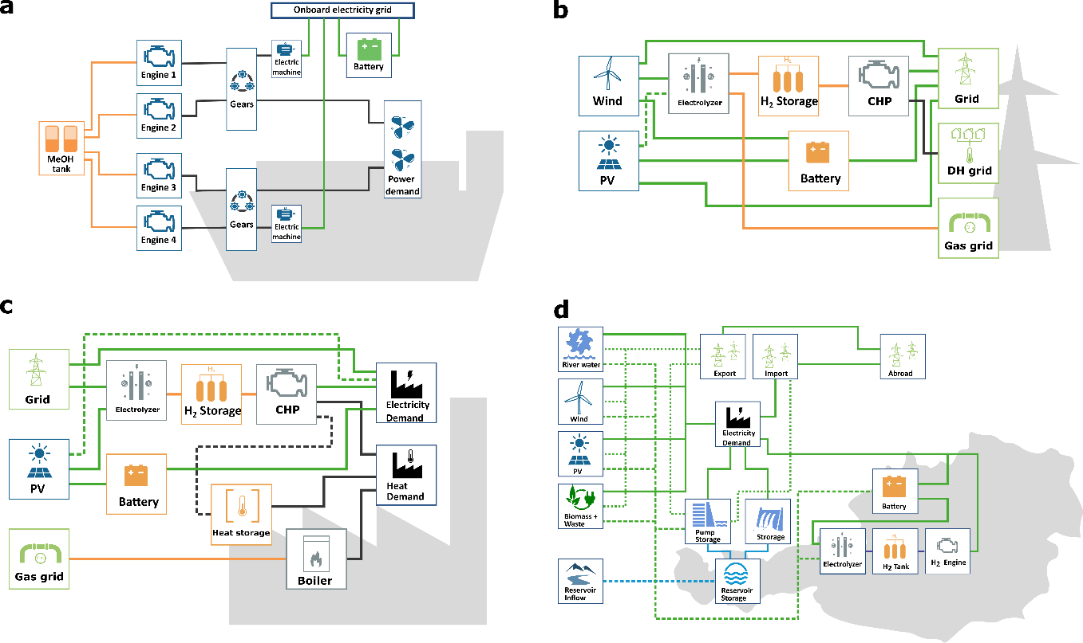
Figure 1: ENERsim system designs for several application examples, including a ship/maritime energy system (a), utility (b) and industrial power plants (c), and a macro-energy system (d).
Application system
A virtual industrial power plant is designed to study a renewable energy system that fully relies on solar primary energy. The power plant consists of various converter units such as an electrolyzer, heat and power cogeneration engine and a heat pump. Both the electric and thermal loads have to be delivered for all hours of a full year; the electric load is set up to be partially flexible for demand-side management.
The main challenges in the chosen system lie in the highly intermittent nature of solar energy, and the strong seasonal imbalance between solar energy availability and the energy loads, especially heat demand. Short- and long-term energy storage units are included in the system to balance demand with energy availability. System operation is simulated via a predictive control scheme, schematically shown in Figure 2. For each time step, the controller calls data-driven models that process the past 24 hour data and weather forecasts to predict the future PV generation and load profiles. These data are fed as boundaries into a digital twin optimizer that optimizes the energy management strategy. The optimized energy flows are used as control parameters for the real system.

Results
The predictive control scheme is compared to optimized operation with perfect foresight over the entire year. Crucial aspects for nearly optimal operation are, besides reliable prediction models, sophisticated hybrid controls that compensate for imperfect prediction, and an incentive for hydrogen production as long-term storage. Because the prediction horizon is limited to typical weather forecast limits, seasonal energy storage is dealt with additional constraints. The results demonstrate that predictive control strategies can enable nearly optimal operation, also for systems that strongly rely on seasonal storage.

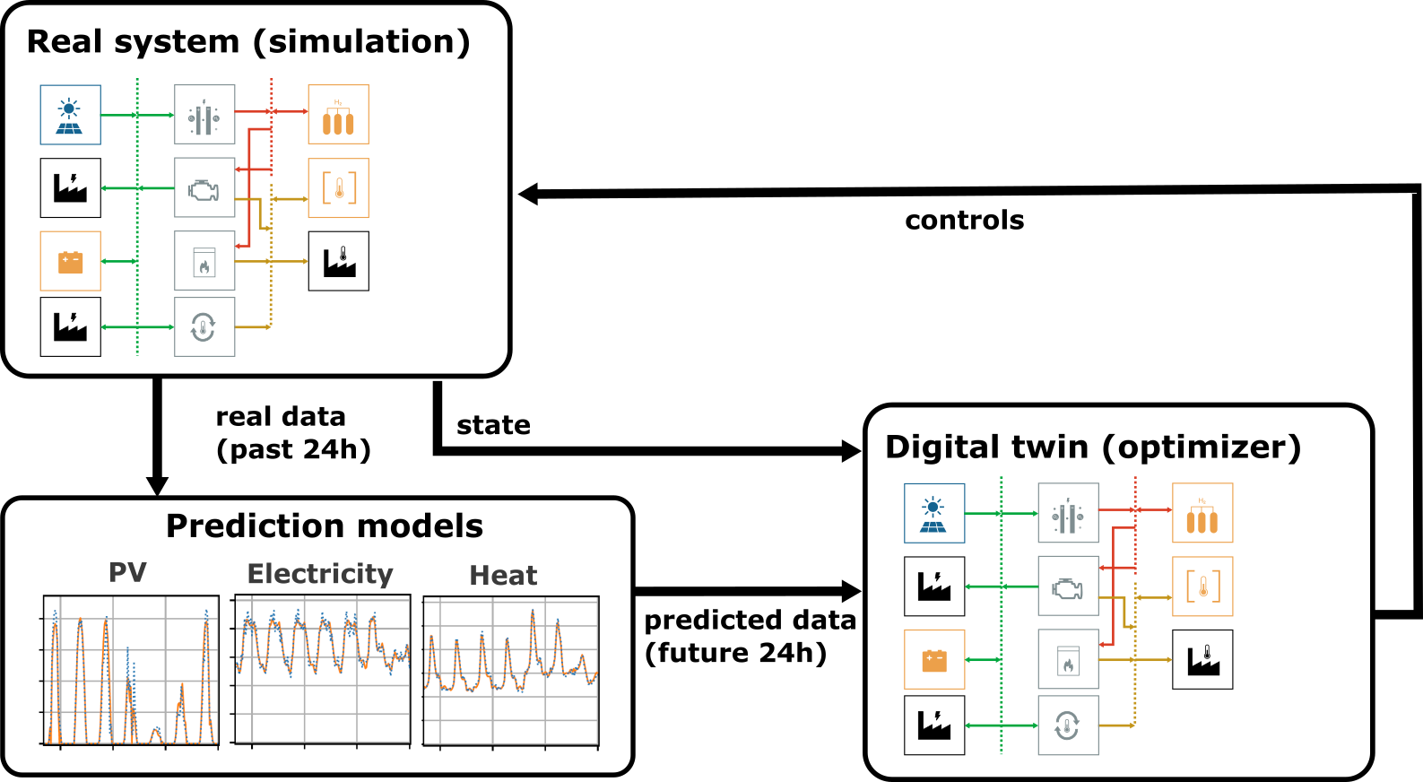
Figure 2: Predictive control concept for an off-grid industrial power plant. The real system is simulated with hourly resolution, and an optimizer uses predicted boundary data to suggest an optimal energy management.

Inffeldgasse 19, 8010 Graz, +43(0)316 873 30111, bernhard.thaler@lec.tugraz.at, https://www.lec.at/

